Size: You’ll end up with the same amount of data at the end (Streaming video/media usually compresses the file though)
Time: Depends on many factors (User’s internet speed, connection strength, bandwidth available on their network, network infrastructure)
Bandwidth: “Streaming” would require less bandwidth on the network. You’re only downloading a question at a time instead of downloading the whole test.
- Discuss with relevant expert or do follow-up research: Would having one question at a time coming into the headset be better or worse for security?

Average Home Download speeds:
9.94-59.48 (Mbps)

Average Upload speeds:
3.35-11.79 (Mbps)

https://www.fastmetrics.com/internet-connection-speed-map-usa.php#average-speeds-usa

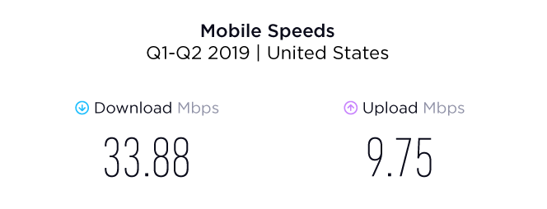
https://www.speedtest.net/reports/united-states/

Need to know the size of the file to understand how the user’s experience will be
- Once we know the size of a test file we will be able to determine what kind of speeds are required.

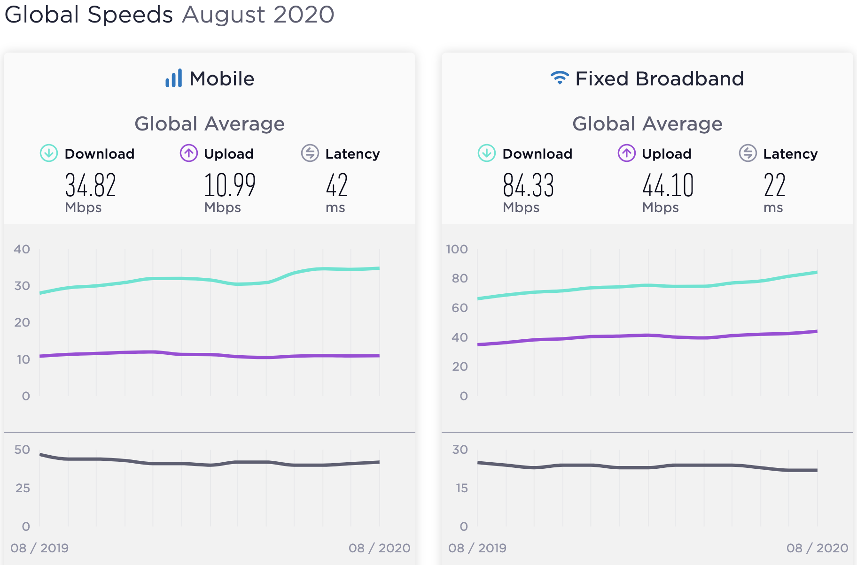
https://www.speedtest.net/global-index

